Implementing Binary Search Trees Using Arrays


static final int TreeSize = 10;
class TreeNode
{
public String Component;
public int LeftChild;
public int RightChild;
};

int root = 0; // Root Always Starts At 0
TreeNode[] L = new TreeNode[TreeSize];

Contents of Array L
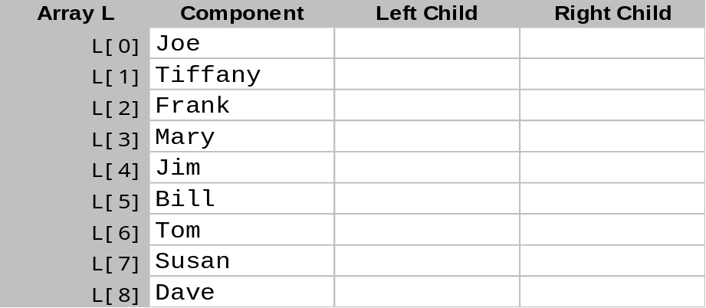An index of 0 represents the root node. Indices of -1 denote no component attached.



